Challenge Details
Terms & Conditions: https://community.blueprism.com/t5/Community-FAQ/Blue-Prism-Social-Warrior-Challenge-Competition-Terms-and/ta-p/125776#M57
Duration:
📅 July 27 – October 27
Challenge Explanation:
The Blue Prism Social Warrior Challenge encourages members of our community to help grow the conversation around Blue Prism by sharing authentic content on LinkedIn, Reddit, or both.
Participants can create original posts, contribute to existing discussions through comments and replies, and engage with others by sharing their experiences, insights, best practices, use cases, or thought leadership related to Blue Prism. The goal is to create genuine, valuable conversations that showcase the expertise of our community and help increase Blue Prism's visibility across social platforms.
Participation is completely optional.

What Counts as a Valid Contribution
Examples include:
- A Linkedin/Reddit post sharing your experience or perspective
- A thoughtful comment on a relevant Linkedin/Reddit discussion
- Answering a question on Linkedin/Reddit where your insight is genuinely useful
- Contextually linking to relevant content only when appropriate
❌ What doesn’t count:
- Spam or promotional posts
- Copy-paste or AI-generated content
- Low-effort engagement (“Great post!”)
- Anything that breaks platform or community rules

Prizes
All participants will receive the brand new social warrior badge to display on your Community profile.
The challenge will be ongoing for 3 months. At the end of months 1 and 2, we will release a check-in leaderboard. The top 3 contributors will win a $30 USD e-gift card. Contribution quality are scored on a rubric.
At the end of the 3 month challenge, the top contributor will receive a $250 USD e-gift card. The 2nd and 3rd runner ups will both receive a $30 USD e-gift card.

LinkedIn

How to Engage
Posting/Reposting
- Create your own post based on your experience in RPA, automation, with Blue Prism, etc.
- Repost Blue Prism content to your own network. Consider adding a short anecdote, personal takeaway, or relevant lesson when doing so.
Commenting
- Comment on Blue Prism Official or Blue Prism-related posts (discussions across automation, AI, operations, agentic automation, RPA)
- Add value only when relevant, no pressure to comment on everything
- Avoid promotional language; maintain a positive, professional tone
- Share personal experience or practical examples

Reddit
Reddit is community-driven and strongly opposed to anything that feels like marketing. The priority here is honest expertise, not promotion.

General Guidelines
- Read and abide by each subreddit’s rules
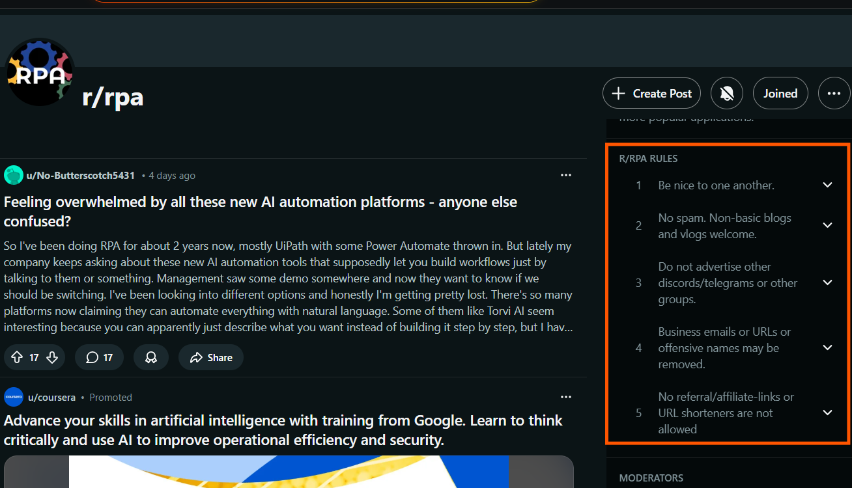
- If mentioning Blue Prism, frame it as your own personal experience, not a product pitch
- If you’re an MVP, be transparent about your role
- Provide balanced, experience-based advice
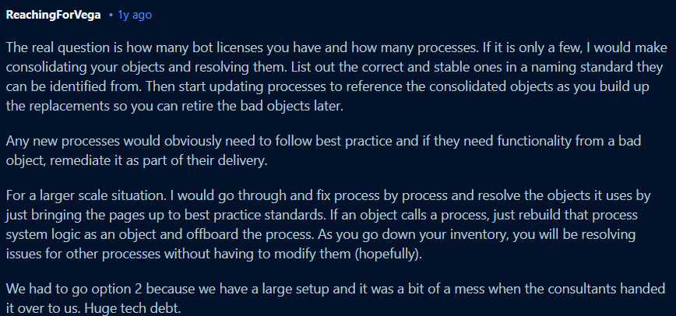
- Use conversational language and avoid overly corporate or professional tones
- Avoid obvious AI-generated content. Reddit values authenticity.

Where and How to Engage
Primary
r/blueprism
- Host AMAs
- Respond to technical and conceptual questions
- Encourage community engagement
Additional subreddits (examples- you can post on anything relevant to your experience)
r/automation
r/rpa
r/devops
r/agenticautomation
Only engage when the question or discussion is relevant to automation, RPA, agentic automation, orchestration, or enterprise operations.
⚠️ Important
Breaking subreddit rules can result in bans. Always stay helpful, neutral, and respectful of community norms.

